Faculty of Engineering, Sciences & Technology



**Web Engineering (Project)**

**BS (SE) – 6th**

Group Members Name:

Muhammad Talha

Abdul Rehman Siddiqui

Syed Saad Ahmed

Omer Irfan

Muhammad Nabeel Ahmed

**Abstract**

E-commerce (electronic commerce or EC) is the buying and selling of goods and services, or the transmitting of funds or data, over an electronic network, primarily the internet. E-commerce is conducted using a variety of applications, such as email, online catalogs and shopping carts, EDI, File Transfer Protocol, and web services. This includes business-to-business activities and outreach such as using email for unsolicited ads (usually viewed as spam) to consumers and other business prospects, as well as to send out e-newsletters to subscribers. More companies now try to entice consumers directly online, using tools such as digital coupons, social media marketing and targeted advertisements. In this project we are offering an admin CMS of buy and sale of your own product so you can easily connect with the each other in this website there is no type of vender intervention or third party so you don’t have to pay more. The interface of this site is very easy so any computer literate can understand. This is basically developed via HTML, CSS, PHP, JAVA and My SQL.

# **introduction**

Our website beachdo is a place where you can possibly “Buy or Sell” just anything for free. This is a platform which opens the wonderful opportunity for you to directly contact with the buyers or sellers while sitting at the comforts of your prized place. Isn’t the experience awesome? Yes, it does. It’s the best available service where buyers meet sellers. No one have to do hard work for selling or purchasing, a platform is here, just post the add with specific requirements and post for free. One who want to purchase search for the relevant add and contact to the seller. You can post, update, delete the add as well. You can also signup to save the details it will make easy to post another add instead of gives detail each time for posting a add. Easily design rich add. It has a colorful schemes that will attract anyone. Access the site from mobile. Easily design rich add.

**Literature review**

# **what new in this**

We know very well there are also a lot of same websites in market which also COINTAIN the CMS portals or admin panel as you are aware of the popular sites like OLX, Daraz.pk, Homeshopping.pk . We are replicating the idea but providing the other features which OLX and other sites are not providing so that we can manage all features easily.

In this the layout of the website is simple and user-friendly even a naive person can understand what we need to do and where we need do go we are not hiding any features and options. We provide the customer one to one connection who so ever is interested to buy their product so in our website there are no enforcement of vender system no any fees or any kind of policy which provide them the facility.

# **History of e-commerce**

Electronic Commerce is process of doing business through computer networks. A person sitting on his chair in front of a computer can access all the facilities of the Internet to buy or sell the products.

Unlike traditional commerce that is carried out physically with effort of a person to go & get products, ecommerce has made it easier for human to reduce physical work and to save time. E-Commerce which was started in early 1990’s has taken a great leap in the world of computers, but the fact that has hindered the growth of e-commerce is security. Security is the challenge facing e-commerce today & there is still a lot of advancement made in the field of security.

The main advantage of e-commerce over traditional commerce is the user can browse online shops, compare prices and order merchandise sitting at home on their PC.

For increasing the use of e-commerce in developing countries the B2B e-commerce is implemented for improving access to global markets for firms in developing countries. For a developing country advancement in the field of e-commerce is essential. The research strategy shows the importance of the e-commerce in developing countries for business applications.

**Methodology**

# **what we use**

We are using simple platform for developing this project like PHP (Personal Home Page) which is website based on PHP. All the main working is done through this for securing the system For example Login Panel with which we will be providing the authentication so that only valid user can get access to the site. The layout is designed using the bootstrap for responsiveness so that it can be open on mobile and desktop with the same view. Also we can give you more feature for attractive sight with the Help of CSS (Central Superior Services) or dynamic website and give you the access for sending email or connect with the admin to user and tell everything what everyone is doing……

# **Working of E-COMMERCE**

The consumer moves through the internet to the merchant's web site. From there, he decides that he wants to purchase something, so he is moved to the online transaction server, where all of the information he gives is encrypted. Once he has placed his order, the information moves through a private gateway to a Processing Network, where the issuing and acquiring banks complete or deny the transaction. This generally takes place in no more than 5-7seconds..

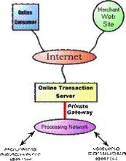

There are many different payment systems available to accommodate the varied processing needs of merchants, from those who have a few orders a day to those who process thousands of transactions daily. With the addition of Secure Layer Technology, E-C0mmerce is also a very safe way to complete transactions

**3 tier architecture**

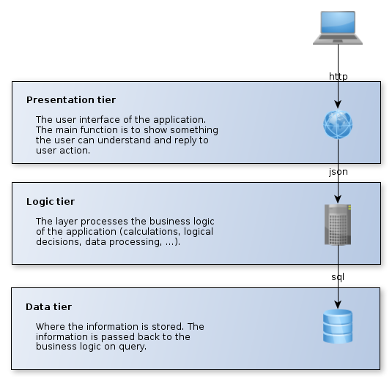

Our Presentation represent 3 tier architecture because I consist of 3 layers. Presentation layer defines its interface and how our website shows data to the user. 2nd layer is an application layer which describe business logics through which client requests are processed. 3rd Layer is a data access layer in which database is connected and is used to fetch required data...

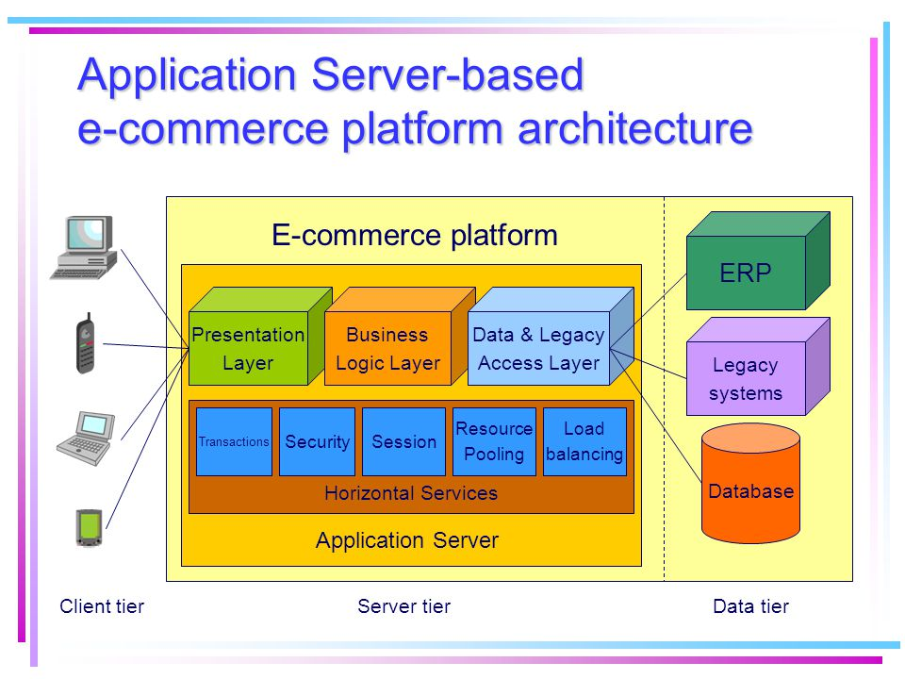

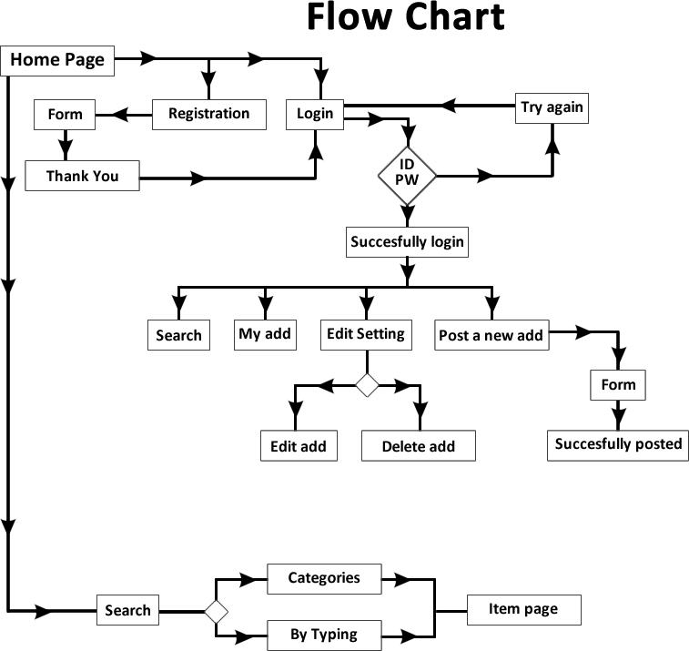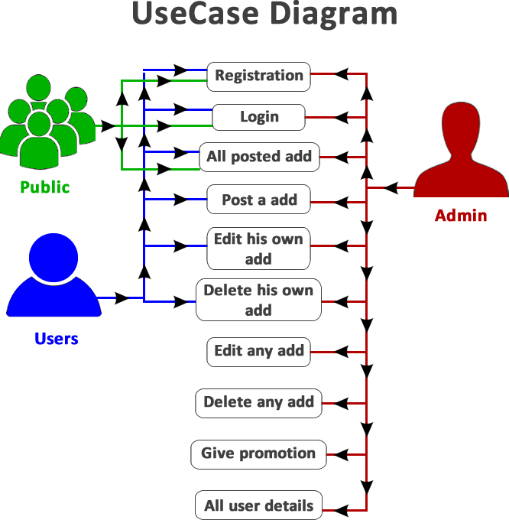

**conclusion**

After careful annotations, it is concluded that e-commerce has undeniably become an important part of our society. The world wide web is and will have a large part in our daily lives. It is therefore critical that small businesses have their own to keep in competition with the larger websites. Since web developers have lowered down the prices for their services, it has become more affordable for small businesses to use the world wide web to sell their products. Although there are negative aspects of e-commerce, small businesses have tried to accommodate to the needs of the consumers. It is also important to note that e-commerce does not benefit all small companies equally. How much revenue a business gets from e-commerce depends on what kind of service it gives. For example, most people would like to try on clothes before they buy them, so it probably would not benefit a small business that sells clothes as much as a small business that sells home supplies or specialty books. Nevertheless, e-commerce does benefit any business even in small ways and it is becoming such a huge part of how society functions that it effects the economy greatly and whatever happens to the economy affects us.

# **Future of E-commerce**

In the foreseeable future ecommerce will further confirm itself a major tool of sale. Successful ecommerce will become a notion inseparable from the web, because e-shopping is becoming more and more popular and natural. At the same time severe rivalry in the sphere of ecommerce services will intensify their development. Thus prevailing future trends of ecommerce will be the growth of Internet sales and evolution.

Each year number of ecommerce deals grows enormously. Sales volumes of on-line stores are more than comparable with those of “brick-and-mortar” ones. And the tendency will continue, because a lot of people are “imprisoned” by work and household duties, while Internet saves a lot of time and gives opportunity to choose goods at the best prices. Present-day Internet sales boom is the foundation for magnificent ecommerce future.

**Reference Links**

https://searchcio.techtarget.com/definition/e-commerce

<http://www.creativeworld9.com/2011/03/abstract-on-e-commerce.html>

http://citeseerx.ist.psu.edu/viewdoc/download?doi=10.1.1.93.4620&rep=rep1&type=pdf

**http://bechdey.000webhostapp.com**